Civil war in Liberia

UNSC Resolution: | 866
Date of adoption: | 22-Sep-1993
Operative paragraph: | 12
Demand number: | 866,1211

Sarah-Myriam Martin-Brûlé

Wording of demand

take all necessary measures to ensure the security and safety of UNOMIL personnel, as well as of the personnel involved in relief operations, and strictly abide by applicable rules of international humanitarian law

List of addressees of the demand
- Government of Liberia, Liberian Peace Council, National Patriotic Front of Liberia, United Liberation Movement of Liberia for Democracy

Short-term compliance

Description of the addressee(s)’ conduct

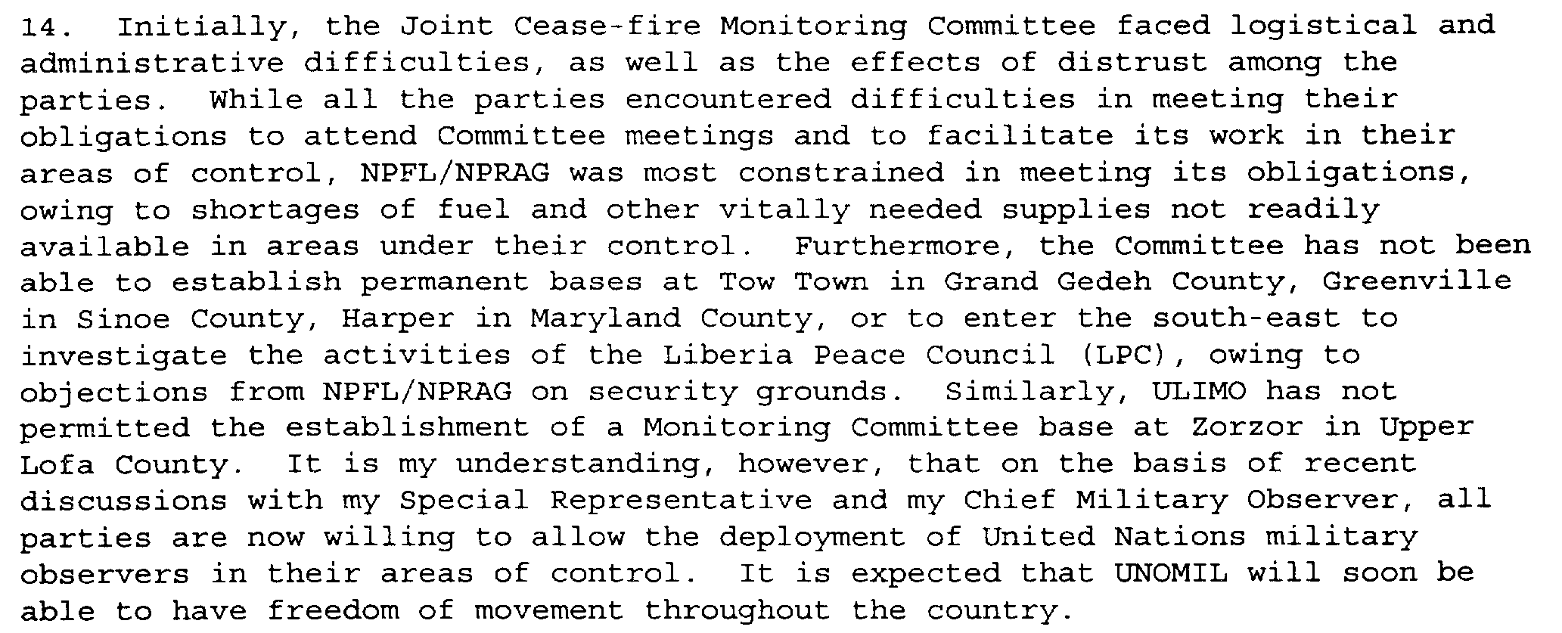

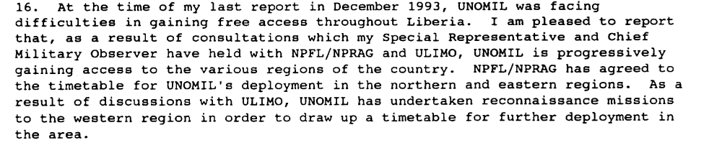

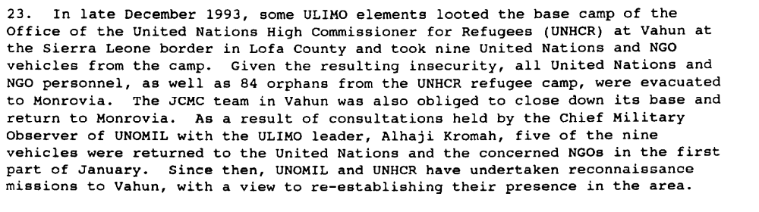

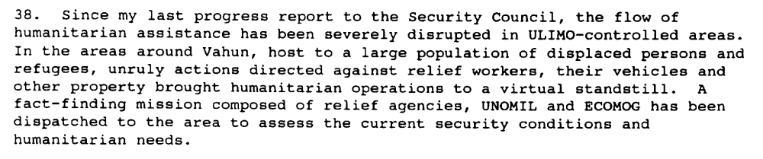

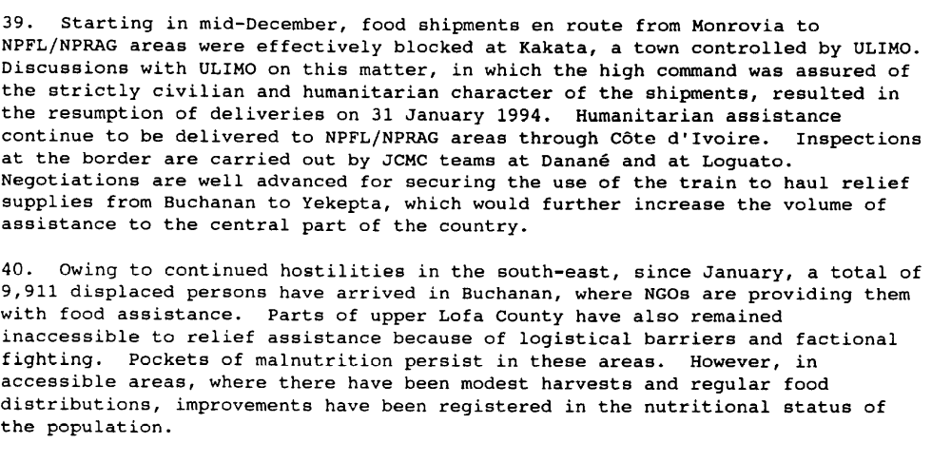

Report of the Secretary-General, S/1994/168

“A disturbing characteristic of the Liberian war has been the use of child soldiers. International law, notably the Protocols of the Geneva Conventions and the United Nations Convention on the Rights of the Child, forbids the use of children under the age of fifteen as soldiers in armed conflict. The African Charter on the Rights of the Child has a higher threshold, stating that no one under the age of eighteen can serve in armed hostilities. In spite of these clear provisions, thousands of children are being used as soldiers in Liberia. There are no precise figures on the number of child soldiers in Liberia; even the total number of combatants in all the factions is unknown, but estimates range between 40,000 and 60,000 combatants. UNICEF estimates that approximately 10 percent of the fighters are under the age of fifteen. The NPFL and ULIMO have consistently used children under the age of eighteen, including thousands of children under fifteen.”
Human rights abuses continued throughout the country by all the warring factions. By mid-September, renewed fighting and attacks on relief workers and other noncombatants, including the capture by NPFL forces of forty-three U.N. observers and six NGO staff who were later released, had forced all relief organizations to recall their staff members to Monrovia. All the fighters continued to act with impunity in their territory, subjecting civilians to a range of abuses, from harassment and detention to arbitrary execution. For its part, the NPFL attacked civilians in its war against the LPC in the southeast, and in the inter-faction fighting that broke out in August. In October, UNICEF reported that about 500 orphaned children, who had been housed in the NPFL capital of Gbarnga, had been moved to Totota, near the battlefront, and were "starving and in grave danger."
ULIMO also engaged in attacks on civilians, looting, and executions. On December 23, 1993, ULIMO attacked the United Nations base in Vahun in Lofa County: U.N. and nongovernmental organizations' vehicles were stolen, and their warehouses were looted. The U.N. was forced to evacuate all its staff, as well as eighty-two orphans. In March 1994, ULIMO split into two factions, Krahn versus Mandingo. The fighting in the western counties has been fierce, with civilians being targeted by both sides. On May 27, the Mandingo faction of ULIMO captured sixteen Nigerian ECOMOG soldiers, blaming them for cooperating with the Krahn faction; they were later released. On June 28, the Krahn faction of ULIMO held five UNOMIL observers hostage and subjected them to humiliating mistreatment. ULIMO is also believed to have been responsible for cross-
border attacks on Liberian refugees in Guinea.”

Human Rights Watch, Human Rights Watch World Report 1995 - Liberia, 1 January 1995, available at: http://www.unhcr.org/refworld/docid/467fca9b1e.html

Assessment

Short-term compliance
X No or marginal compliance (1) | Medium low compliance (2) | Medium high compliance (3) | Full or almost full compliance (4)

Considerations underlying the assessment
The ill-treatment of civilians, the targeting of UNOMIL personnel show that the demand addressees did not comply with this demand.

Medium-term compliance

Description of the addressee(s)’ conduct

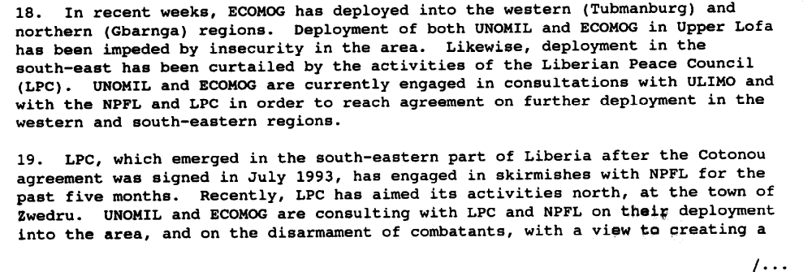

Third Progress Report of the Secretary-General on the United Nations Observer Mission in Liberia, S/1994/463, 18 April 1994

At its 3404th meeting, on 13 July 1994, the Security Council included in its
agenda the report of the Secretary-General of 24 June 1994:

“The Council expresses its concern about the increase in military activities being carried
out in violation of the general cease-fire and the consequent large-scale displacement of
persons and atrocities which have been committed throughout the country. The Council
condemns all those who initiate fighting and who violate international humanitarian law.
“The Council strongly deplores attacks on and the abduction and harassment of United
Nations and Economic Community of West African States Monitoring Group personnel in Liberia, as well as looting of United Nations and Monitoring Group property. It demands that such hostile acts cease forthwith.
“The Council urges the Liberian parties to take all necessary measures to ensure the
security and safety of Mission and Monitoring Group personnel, as well as of the personnel involved in relief operations, and strictly to abide by the applicable rules of international humanitarian law. It demands that all factions in Liberia extend full cooperation to organizations engaged in the delivery of humanitarian assistance.
“The Council commends the positive role of the Economic Community of West African
States in its continued efforts to facilitate “
(…)

“At its 3424 th meeting, on 13 September 1994, the Security Council resumed its
consideration of the situation in Liberia. After the adoption of the agenda, the President
(Spain) stated that, following consultations among members of the Security Council, he
had been authorized to make the following statement on behalf of the Council:
“The Security Council strongly condemns the detention and mistreatment of forty-three
unarmed military observers of the United Nations Observer Mission in Liberia and six staff members of non-governmental organizations, in flagrant violation of international
humanitarian law as well as of the Cotonou Agreement (S/26272, annex). It demands that
those responsible release immediately the detained personnel and return their property and that of the Mission and humanitarian organizations”

Chapter 8, “Repertoire of the Security Council”
http://www.un.org/fr/sc/repertoire/93-95/CHAPTER%208/AFRICA/item%2005-%20Liberia.pdf

Assessment

Medium-term compliance
X No or marginal compliance (1) | Medium low compliance (2) | Medium high compliance (3) | Full or almost full compliance (4)

Considerations underlying the assessment

The parties continued to target civilians and to prey on UNOMIL personnel to bolster their power and control over the territory. They did not comply with this demand within the two years following the adoption of the resolution.

Depth of demand

Assessment

Level of depth of demand
Low depth of demand (1) | X Medium depth of demand (2) | High depth of demand (3)

Considerations underlying the assessment
Compliance with this demand would have made it significantly more difficult for some of the addressees to achieve victory. The violation of humanitarian law was used as a military strategy to gain power over the adversaries (deprive them of their civilian support base, send costly signaling of their intentions to win the war or to gain access\control over a territory, etc.).

Level of confidence about coding decisions

Level of confidence about coding decision
Extremely high | X High | Moderate

Comments to IPI (if any)

